ST MICHAEL AND ALL ANGELS CHURCH BEDFORD PARK

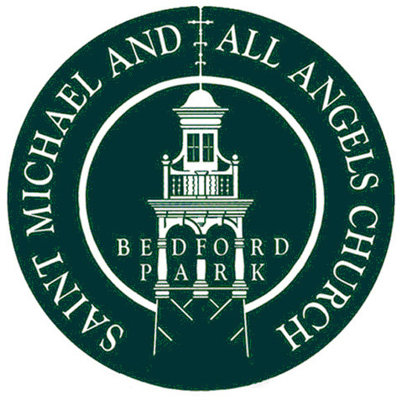

Parish Meeting
and
Annual Parochial Church Meeting
To be held in the Church Hall on Sunday 10th May 2026 at 11.15am

Agenda

- Parish Meeting

- Election of Churchwardens: Christina Whiteway and Peter Haigh.

- Annual Parochial Church Meeting

- Notice of Meeting: posted two weeks in advance.

- Apologies for Absence.

- Minutes of the 2025 APCM

- Matters Arising from the Minutes.

- Election of Lay Members to the PCC: nominations have been received for Marjolein van Kampen; Jane Thomson; Jim Russell (standing for a second term of office); Judy Donner (co-opted Nov.2025, now standing for a full term of office).

- Election of SMAAA representatives to the Hounslow Deanery Synod: nominations have been received for Christina Whiteway, Judy Donner and Alison Baker.

- To Receive the Annual Report and Accounts for 2025.

- Financial Overview for 2025

- Re-appointment of the Independent Examiner: Reddi Siddiqui LLP.
- Report on the Electoral Roll

- Fabric Report.

- St Michael’s in 2025: slideshow.

- Any Other Business: to be submitted to the secretary (via the parish office) by 3rd May 2026.

