
Crane Press Ltd
London
Stranded in France
by Joan Langrish and Sally Mercer
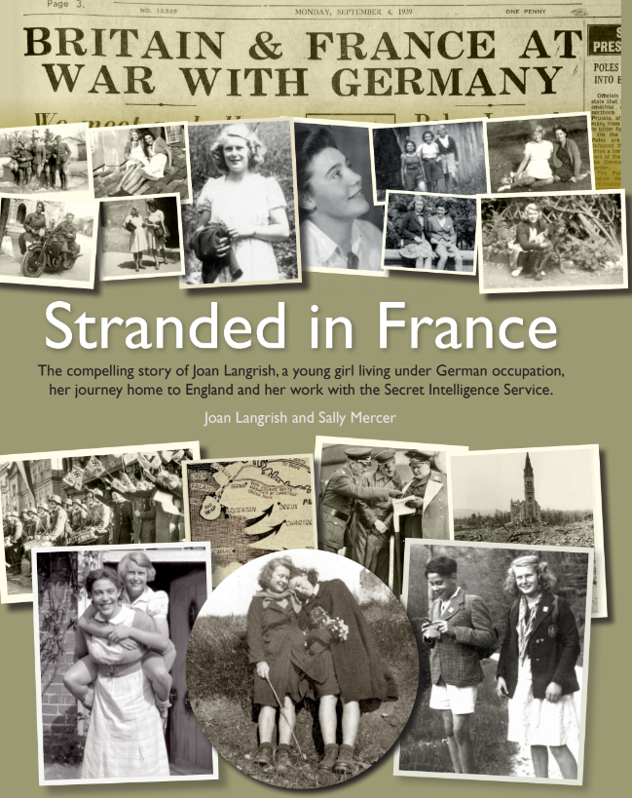

About the book:
On the declaration of WW2, 16 year old Joan was left stranded in France, only weeks after having arrived at her French exchange. She remained hidden in plain sight for 2 years. Joan paints a vivid picture of blending into French life, caring for injured soldiers and families fleeing German fire, carrying notes to French soldiers. Finally, she escaped back into a blacked-out England in the dead of night with gold coins sewn into the hem of her dress to give to Charles de Gaulle.
Back home, she was recruited into the Secret Intelligence Service working as a top-level secretary. She worked under Kim Philby, the most notorious double agent in the history of British intelligence, and rubbed shoulders with Graham Greene, Ian Fleming and Charles Cholmondeley, a key figure in Operation Mincemeat.
Hers is a story of innocence quickly growing into resilience, a keen intelligence and fierce sense of loyalty and honour during one of the most turbulent times of British History. It is for the enrichment of us all that Joan has shared her unique story during WW2, for us not only to learn from but to appreciate how lucky we are in times of peace.

TPS: 280 x 217 mm
Format: Full colour, 157 gsm matt art paper, Sewn, 3mmm boards
Hardcover Edition, case wrapped and laminated board with 157 gsm full colour jacket
Extent: 80 pp
Packing: 16 per carton
Manufactured in China
UK RRP: £15
ISBN: 978-1-911060-46-8
Contact: David@cranepressltd.com
https://www.paypal.com/paypalme/StrandedinFrance/15GBP

