St Michael & All Angels Parish Church London W4 1TX
by Turnham Green Tube Station
2012 Lent Course

De-Coding Handel’s
Messiah

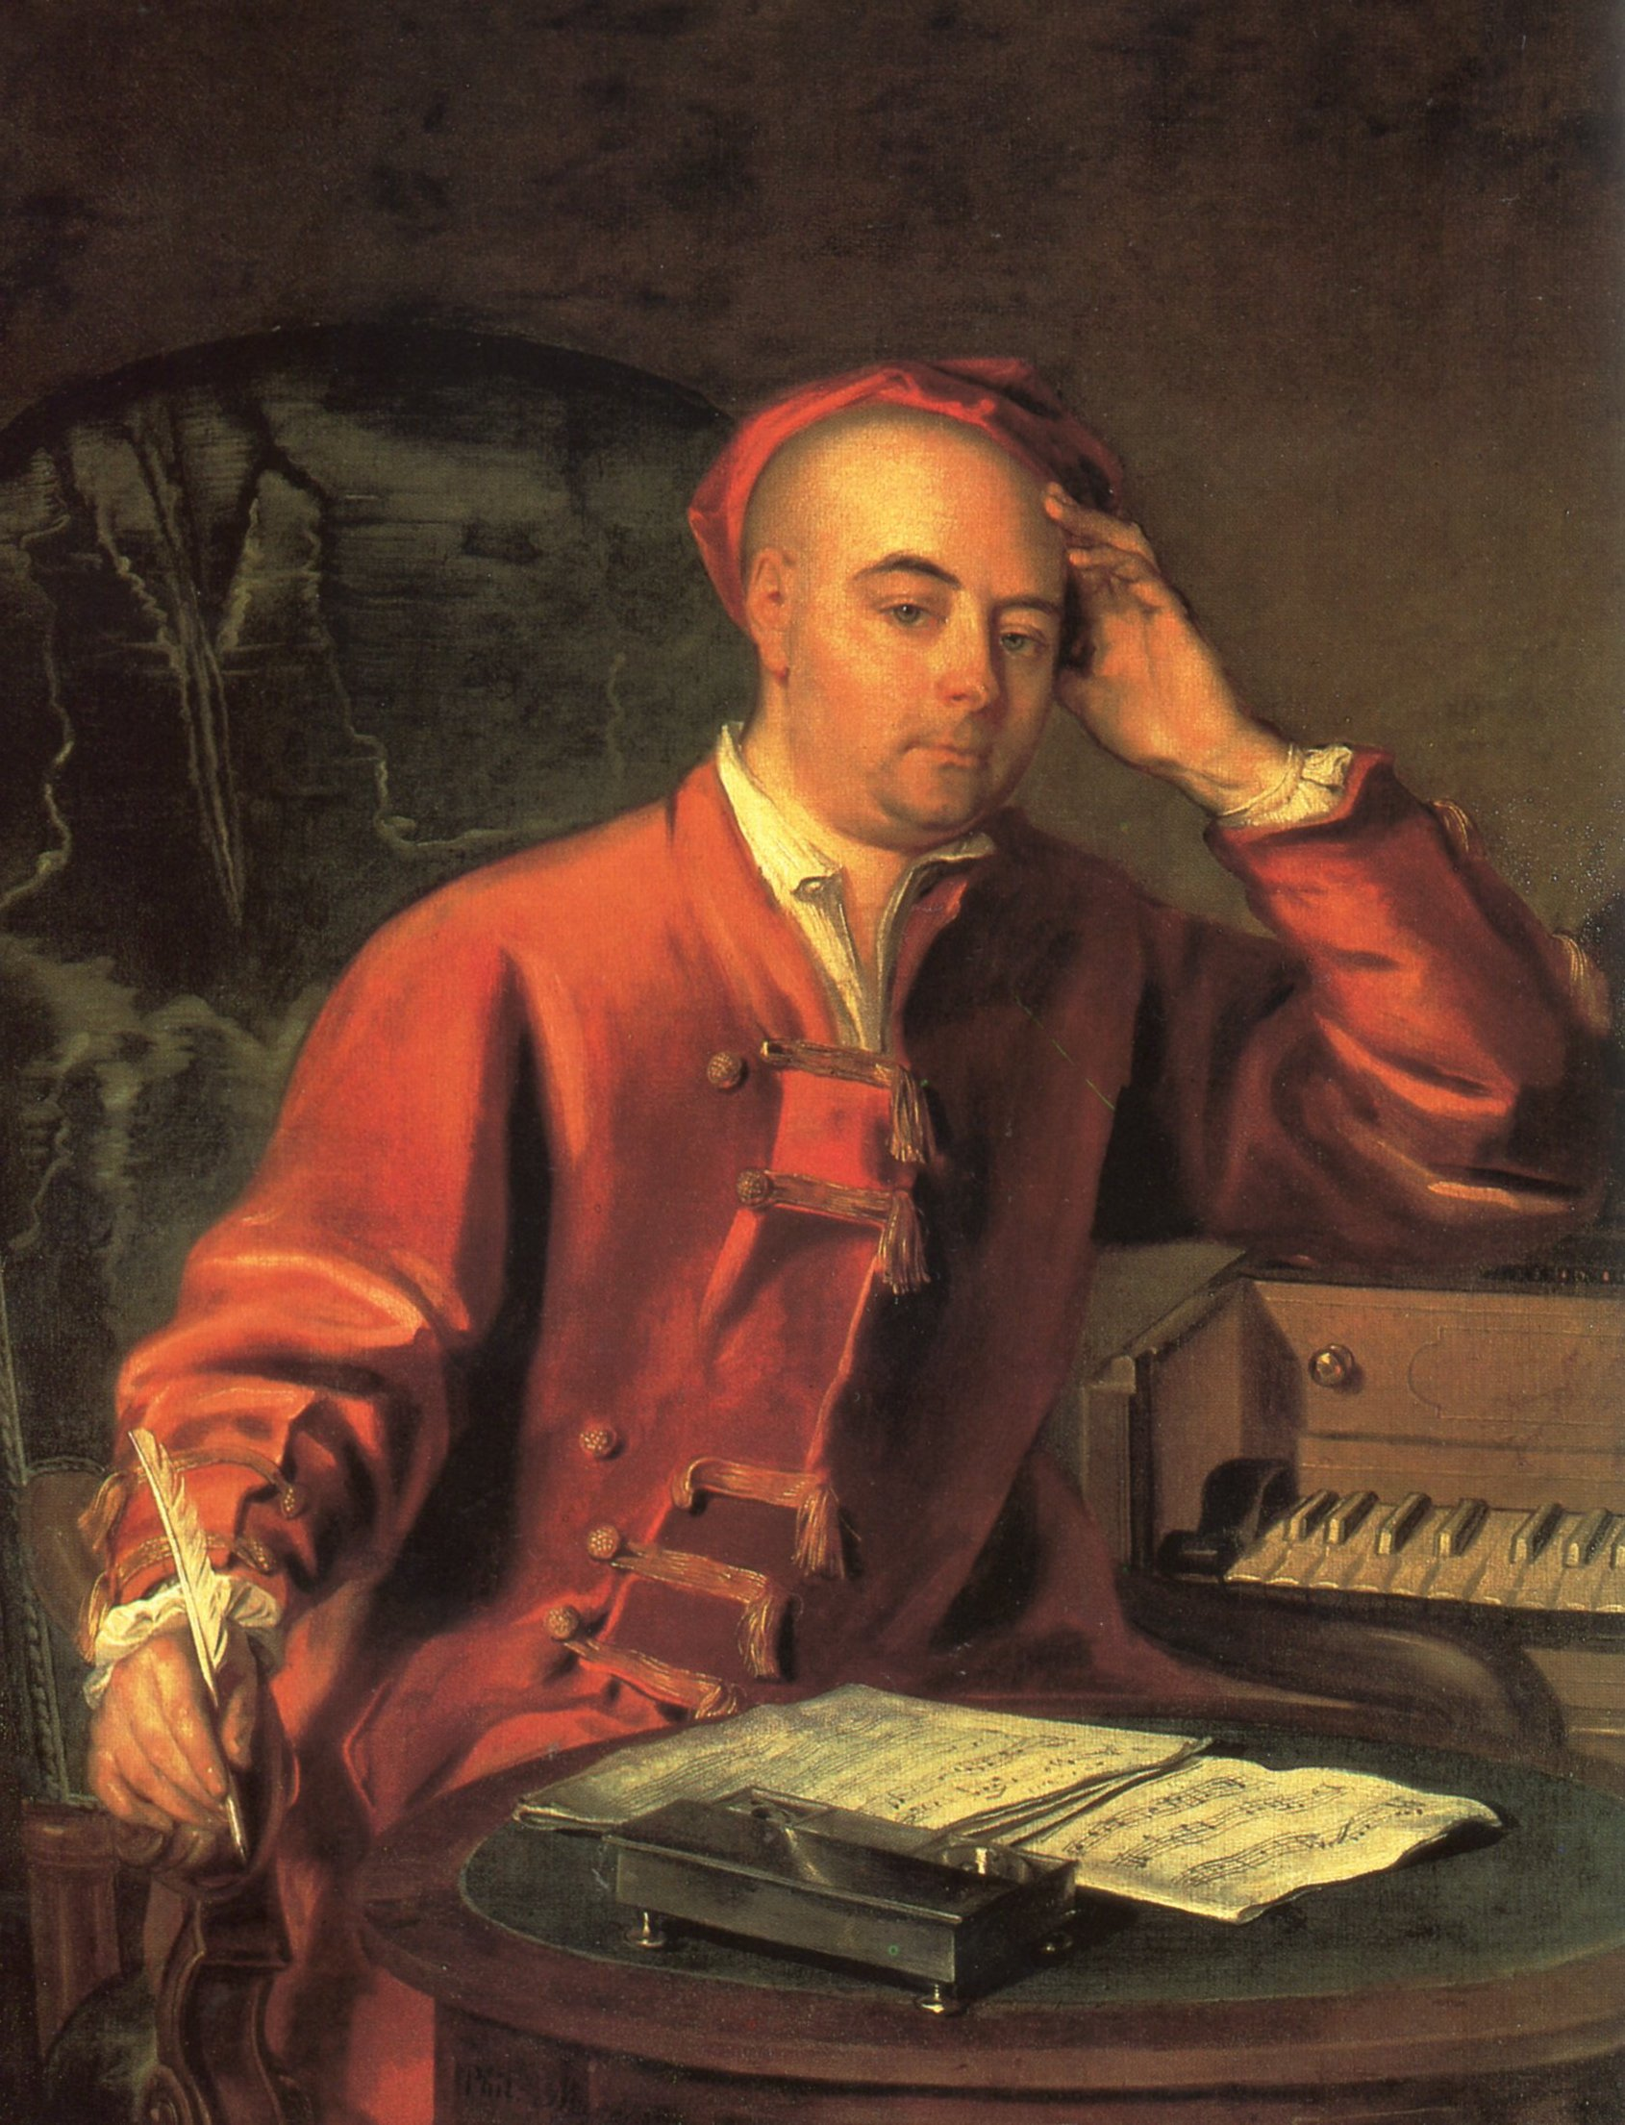

What is the plot?
What does it mean?
And what has it got to do with Easter?

Come to a four-part course with music and PowerPoint slides

led by Sarah Lenton

on Wednesdays the 7, 14, 21 and 28 March
at 8 pm in the Church Hall Raphael Room
Entrance via Church carpark in
Priory Avenue at back of Church

www.smaaa.org.uk
email parishoffice@smaaa.org.uk
Tel (office hours only) 020 8994 1380

Sarah Lenton
Is a specialist on Handel and a well-known lecturer on opera for the Royal Opera House and for BBC Radios 3 and 4. Her most recent broadcast was ‘Building a Library’ for BBC Radio 3 on Handel’s opera Julius Caesar.
She read Theology at King’s College London and preaches regularly at St Michael and All Angels, Chiswick, and at All Hallows, Twickenham. As a writer and cartoonist, her current trilogy for Canterbury Press, Creative Ideas for Children’s Worship: Years A & B (Year C follows this autumn) has been a great success with Anglican and Roman Catholic parishes for use in their work with children and at Family Mass.
Her book De-Coding Handel’s ‘Messiah’ will be based on these Lent Course sessions.

