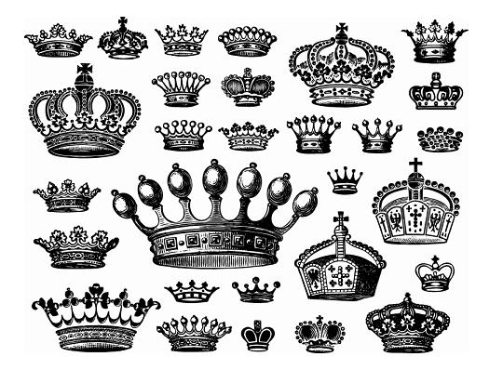Design A Crown Competition

Diamond Jubilee Celebration with Marmalade Jewellery

Win a family day out at the Tower of London

to see the real Crown Jewels

Draw, paint or make a beautiful crown fit for a Queen.

Drop your picture off at Marmalade Jewellery before Friday the 15th June – all entries displayed at the Bedford Park Festival.

Winner announced at the fancy dress parade at the Bedford Park Festival – 16th June
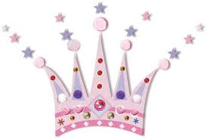 | 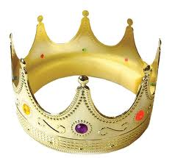 | 